**DAILY ONLINE ACTIVITIES SUMMARY**

|  |  |  |  |  |  |  |  |  |
| --- | --- | --- | --- | --- | --- | --- | --- | --- |
| **Date:** | **27/05/2020** | | | | | **Name:** | **PRANEETA P HANDRAL** | |
| **Sem & Sec** | **4​th​ SEM. & ‘B’ SEC.** | | | | | **USN:** | **4AL19CS401** | |
| **Online Test Summary** | | | | | | | | |
| **Subject** | | **OBJECT ORIENTED CONCEPTS** | | | | | | |
| **Max. Marks** | | **30** | | **Score** | | | **22** | |
| **Certification Course Summar3y** | | | | | | | | |
| **Course** | **Python for Machine Learning** | | | | | | | |
| **Certificate Provider** | | | **Greatlearning academy** | | **Duration** | | | **5 Hrs.** |
| **Coding Challenges** | | | | | | | | |
| **Problem Statement:** **Given an array arr[] of the positive integers of size N, the task is to find the largest element on the left side of each index which is smaller than the element present at that index. Note: If no such element is found then print -1.**  **Problem Statement:** **In Bubble sort, each pass consists of comparison each element in the file with its successor (i.e. x[i] with x[i+1]) and interchanging two elements if they are not in the proper order. The array may be sorted in any pass. If the array is sorted, then remaining passes should be skipped off.Write a C Program to sort an array of integers in ascending order and display the sorted array and Number of passes performed for sorting.** | | | | | | | | |
| **Status:** **Executed.** | | | | | | | | |
| **Uploaded the report in Github** | | | | | **Yes** | | | |
| **If yes Repository name** | | | | | **LockdownCoding** | | | |
| **Uploaded the report in slack** | | | | | **Yes** | | | |

**Online Test Summary:​ 18CS45 online test was scheduled from 9:15 am t0 9:45 am .The portion for the IA was 5th module, the questions were MCQ type. There were 30 questions of 1 mark respectively.**

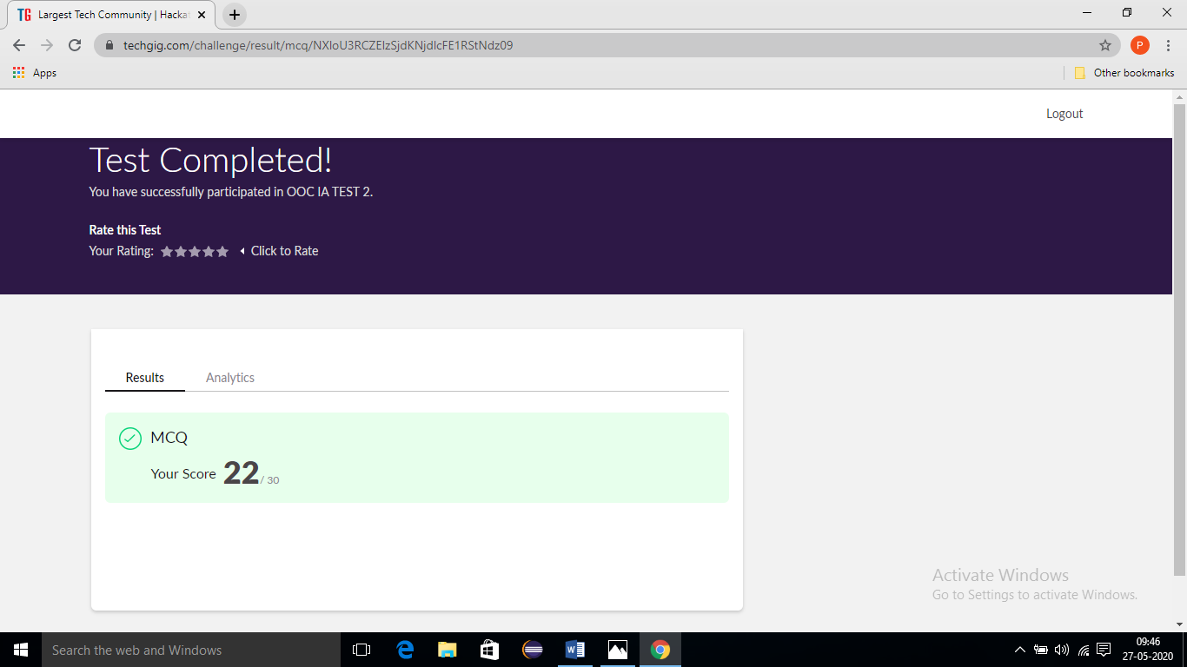

**Online Certification Course Summary​:** **Today I have learn about Saving & loading NumPy Arrays and also execute the some of the basic NumPy programs . NumPy, which stands for Numerical Python, is a library consisting of multidimensional array objects and a collection of routines for processing those arrays.  It is shown in the below snapshot.**

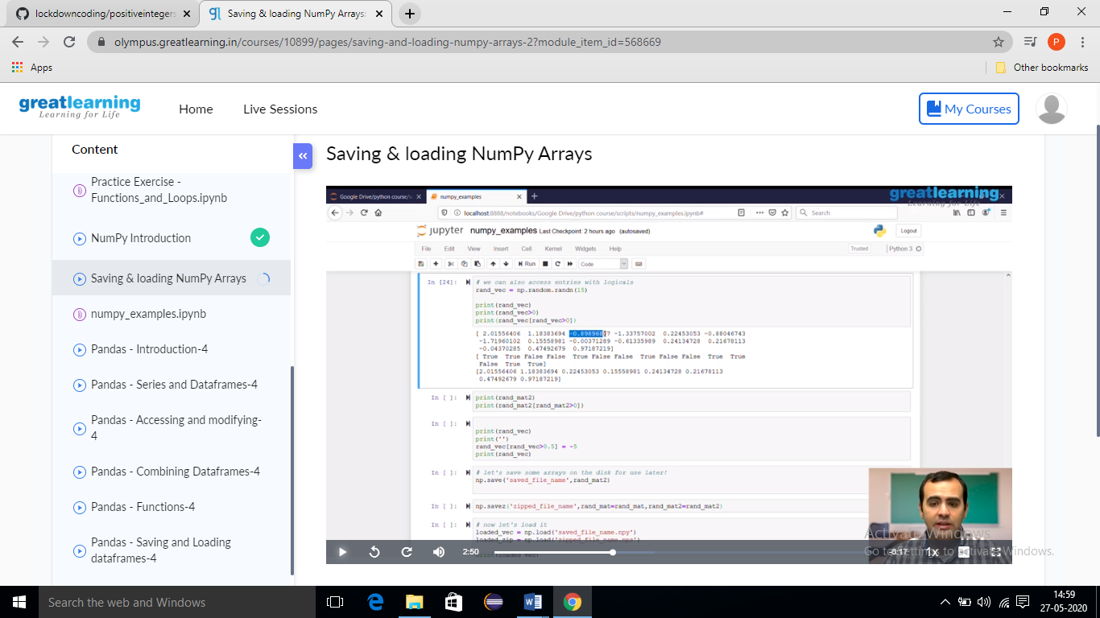

**Online coding Summary:** **Today I received two program one from Prof.Venkatesh CSE Dept another one from Prof. vasudev CSE Dept The program is mentioned above. to my GitHub repository and I’ve shared the snapshot below.**

